Create Application using the PreparedStatement Object:
Sometimes it is more convenient to use a PreparedStatement object for sending SQL statements to the database. This special type of statement is derived from the more general class, Statement that you already know.
If you want to execute a Statement object many times, it usually reduces execution time to use a PreparedStatement object instead.
The main feature of a PreparedStatement object is that, unlike a Statement object, it is given a SQL statement when it is created. The advantage to this is that in most cases, this SQL statement is sent to the DBMS right away, where it is compiled. As a result, the PreparedStatement object contains not just a SQL statement, but a SQL statement that has been precompiled. This means that when the PreparedStatement is executed, the DBMS can just run the PreparedStatement SQL statement without having to compile it first.
Although PreparedStatement objects can be used for SQL statements with no parameters, you probably use them most often for SQL statements that take parameters. The advantage of using SQL statements that take parameters is that you can use the same statement and supply it with different values each time you execute it. Examples of this are in the following sections.
Syntax:
public interface PreparedStatement extends Statement
It is an object that represents a precompiled SQL statement.
A SQL statement is precompiled and stored in a PreparedStatement object. This object can then be used to efficiently execute this statement multiple times.
Please refer the following link for more detail:
https://docs.oracle.com/javase/7/docs/api/java/sql/PreparedStatement.html

Managing Database Transactions
There are times when you do not want one statement to take effect unless another one completes. For example, when the proprietor of The Coffee Break updates the amount of coffee sold each week, the proprietor will also want to update the total amount sold to date. However, the amount sold per week and the total amount sold should be updated at the same time; otherwise, the data will be inconsistent. The way to be sure that either both actions occur or neither action occurs is to use a transaction. A transaction is a set of one or more statements that are executed as a unit, so either all of the statements are executed, or none of the statements is executed.
When a connection is created, it is in auto-commit mode. This means that each individual SQL statement is treated as a transaction and is automatically committed right after it is executed.
The way to allow two or more statements to be grouped into a transaction is to disable the auto-commit mode. This is demonstrated in the following code, where con is an active connection:
con.setAutoCommit(false);
The ACID property describes the transaction management well. ACID stands for Atomicity, Consistency, isolation and durability.
Atomicity means either all successful or none.
Consistency ensures bringing the database from one consistent state to another consistent state.
Isolation ensures that transaction is isolated from other transaction.
Durability means once a transaction has been committed, it will remain so, even in the event of errors, power loss etc.
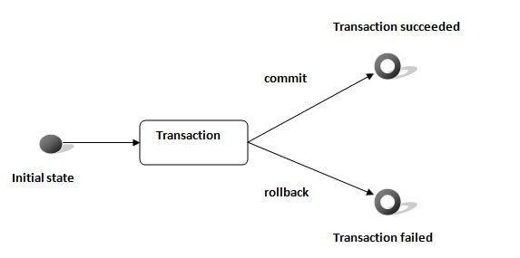
Example:
public void insertData(Book book, String commitStatus) {
try {
con.setAutoCommit(false);
} catch (SQLException e2) {
System.out.println(e2.getMessage());
}
try {
stmt = con.prepareStatement("INSERT INTO Book (book_id, book_price, book_name) VALUES (?,?,?);");
stmt.setInt(1, book.getBook_id());
stmt.setInt(2, book.getBook_price());
stmt.setString(3, book.getBook_name());
int i = stmt.executeUpdate();
if (commitStatus.equals("commit")) {
con.commit();
System.out.println(commitStatus);
}
if (commitStatus.equals("rollback")) {
con.rollback();
System.out.println(commitStatus);
}
System.out.println(i);
} catch (SQLException e) {
try {
con.rollback();
} catch (SQLException e1) {
System.out.println("Hello " + e.getMessage());
}
System.out.println("Hello " + e.getMessage());
}
}
Implementing Batch Updates in JDBC
Batch Processing allows you to group related SQL statements into a batch and submit them with one call to the database. Instead of executing a single query, we can execute a batch (group) of queries.
The java.sql.Statement and java.sql.PreparedStatement interfaces provide methods for batch processing.
public void insertBookRecords(List<Book> books) {
int i = 0;
try {
con.setAutoCommit(false);

for (Book book : books) {
stmt = con.prepareStatement("INSERT INTO Book (book_id, book_price, book_name) VALUES (?,?,?);");
stmt.setInt(1, book.getBook_id());
stmt.setInt(2, book.getBook_price());
stmt.setString(3, book.getBook_name());
i = i + stmt.executeUpdate();
stmt.addBatch();
}
stmt.executeBatch();
con.commit();
System.out.println(i + " rows updated.");
} catch (SQLException e) {
try {
con.rollback();
} catch (SQLException e1) {
System.out.println(e.getMessage());
}
System.out.println(e.getMessage());
} finally {
try {
con.close();
} catch (SQLException e) {
System.out.println(e.getMessage());
}
}
}
Creating and calling Store Procedure in JDBC
Create the sp:
DELIMITER $$
CREATE PROCEDURE GetTotalBooks()
BEGIN
DECLARE totalBooks INT DEFAULT 0;
SELECT COUNT(*)
INTO totalBooks
FROM Book;
SELECT totalBooks;
END$$
DELIMITER ;

CALL GetTotalBooks();
In Java
CallableStatement stmt;
try {
stmt = con.prepareCall("{CALL GetTotalBooks()}");
ResultSet rs = stmt.executeQuery();
while (rs.next()) {
System.out.println(rs.getInt(1));
}
} catch (SQLException e) {
System.out.println(e.getMessage());
}
Using Metadata in JDBC

